Be Cool-Car Pool
A project for 159356
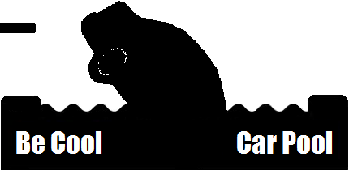

04 August 2008
By: Arlo, Ben, James, Jordan, Parul & Sam

Table of Contents

1. Introduction 2
2. Project Methodology 2
3. Project Plan
3.1 Scope 3
3.2 Gantt chart 4
4. Design Documentation
4.1 Domain Model 6
4.2 Use Case Diagram 7
4.3 Use Cases 8
5. Risk Mitigation Monitoring and Management 14
6. Software Quality Assurance
6.1 Unit testing 16
6.2 Usability Testing 17
6.3 Compatibility Testing 17
6.4 Integration Testing 17
6.5 Process Monitoring 17
6.6 JDepend 18

1. Introduction

Car Pool is an online system being developed to encourage and manage car pooling in New Zealand. Users register for the service and can use existing Open ID compliant user accounts for this purpose. Users will be able to request rides, offer rides and accept offers or requests for rides. When an offer is made or accepted the ride is added as an event to the user’s Google Calendar. This calendar can then send the user automated emails regarding updates on their ride. Each user has a social score which is helpful for drivers and riders to identify who contributes to the car pooling community and find out if someone is good or bad rider or driver.

2. Project Methodology

For our project we have decided to combine the principles of the Agile methodology with the process framework of Rational Unified Process (RUP). The RUP process framework will be applied to each of the three iterations we have to produce – the first, second, and final prototype, as defined by our customers (the lecturers). A single iteration is expected to result in a working part of the system being built and multiple iterations (in our case three) are expected to result in the fully integrated complete product.

RUP has the following four phases: Inception, Elaboration, Construction and Transition. Inception and Elaboration involve identifying the various actors with which the system will interact and defining the nature of this interaction. To this end we will develop design documentation that will help us define the scope of our project. We will do this using Unified Modeling Language (UML) for the most part. A risk assessment, which we will do in the form of Risk Mitigation Monitoring and Management (RMMM), and a project plan, which we will define using a Gantt chart and outlining the scope for each iteration, is also expected from the aforementioned phases. These will be ‘live’ documents that are expected to evolve and change over the course of various iterations. The Construction phase involves the actual building of the components along with integration and testing. And finally the Transition stage involves ironing out any tiny problems and putting in features that were postponed. As stated before all iterations will have all four of these phases.

RUP recommends modeling visually which is why UML will be used to create the design documentation. The modeling will be done in a Just in Time (JIT) basis as prescribed by Agile methodologies. This means that the scope of the model will be restricted roughly to what is required to be implemented in the near future (e.g. 3-4 weeks). Agile methodologies prescribe avoiding Big Design Upfront (BDUF) because requirements are expected to change over the course of the project anyway! The same principle will be applied to our project plan. Our Gantt chart will focus on planning in detail for the near future for the most part and continually we will continually reassess and extend the chart depending on how the project proceeds. Agile methodologies also prescribe addressing priority features at a time which is why at the beginning of the project a scope will be identified for each of the three iterations which will define what features will be developed for that iteration. Finally, it is recommended that standard routinies be automated and we intend to do this through ANT scripts.

3. Project Plan

3.1 Project Scope

Below appear the scopes for our first, second and final prototype. These have changed and will continue to change as the project continues depending on how well or bad our progress for a particular iteration is proceeding.

Scope for Prototype One

The aim of the first prototype is to achieve successful integration of calendar, database and user login with the website.
- Users can register for system using Open ID accounts
- Users can log into system successfully
- Users can add an offer a one-off ride, specify location from and to, make additional detailed comments and specify the date and time.
- This date and time gets added to user’s Google Calendar if they have one.
- Users can accept a Ride.
- The database of users and locations can communicate with the web interface.

Scope for Prototype Two

The aim of the second prototype is to evolve the website into a more secure, user-friendly version with most of the functionality that one would expect from a car pooling site working
- Users will be able to register for the site using their username and password if they do not have an Open ID
- Users can offer and request regularly scheduled rides, specify ‘via’ which locations they are traveling, specify number of seats (which the system can appropriately reduce when someone accepts) and specify if a return or one way ride is needed.
- The users will be able to specify more than one date or day for traveling.
- Google Maps will be integrated with the ride page to illustrate the locations the ride will pass during its travel.
- Users can talk to each other via the comments section of a ride page before accepting a ride offer or request.
- Users can accept a requested ride or create a counter offer.
- Users can withdraw rides or edit their details within a certain amount of time
- A social scoring system will be implemented.
- Users will be able to search for rides
- The web interface will be more secure i.e. fields will be constrained on what types of text they can accept.

Scope for Prototype Three

The aim of the final prototype is to achieve the maximum usability, optimization and security we can for the website and solve any unresolved issues.
- Ride events will be able to be added to any calendar the user wants not just the Google calendar.
- The website will follow good HCI principles.
- Any concurrency issues will be resolved
- Users can have an RSS feed for Rides from and to certain locations that they are interested in.
- Security issues will be resolved
- Optimization issues will be resolved

3.2 Gantt chart

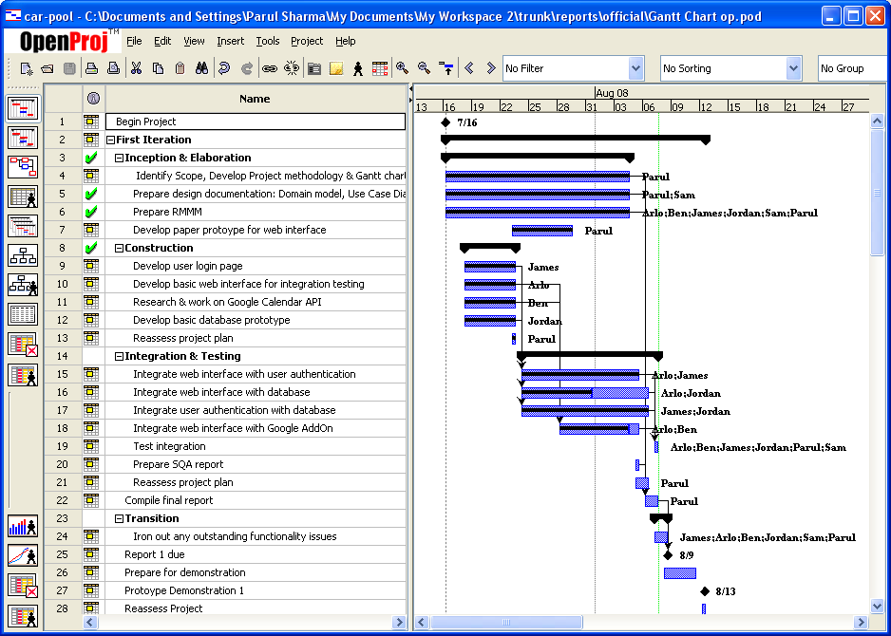
Figure 1: Gantt chart – First Iteration
The Project Gantt chart is continually updated as the project proceeds. The first iteration, displayed in Figure 1, was focused towards gaining an overview of the system that will be developed, creating the most basic features required and ensuring the various components that will make up the system are integrated well together.

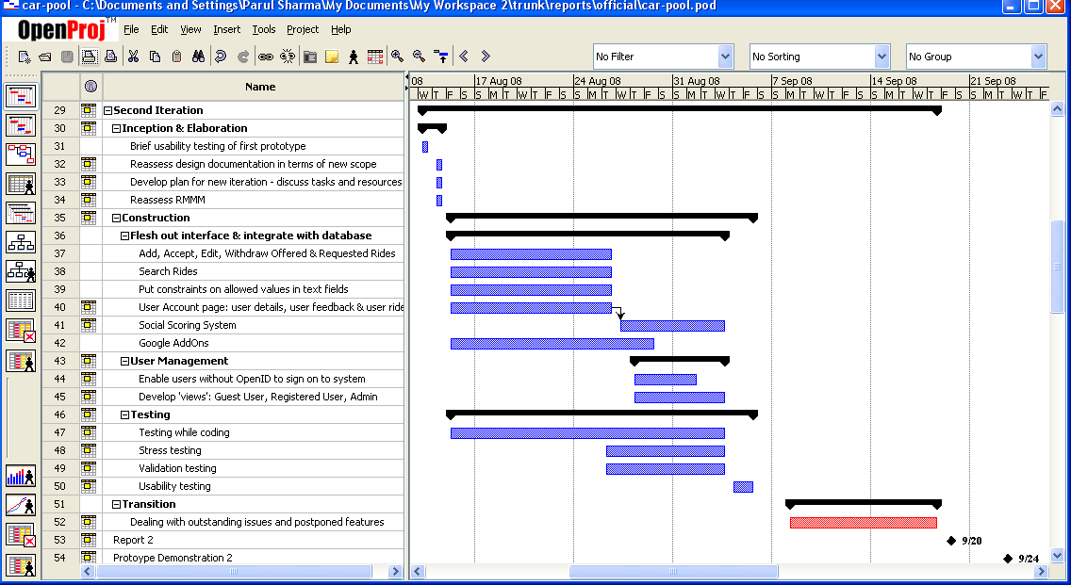
Figure 2 : Gantt chart - Second iteration

The second iteration, displayed in Figure 2, will focus on expanding the features that will be available through the system. Though a ‘bare bones’ outline of how the second iteration will proceed has been created resources will be allocated and this plan reassessed once the first prototype has been demonstrated.

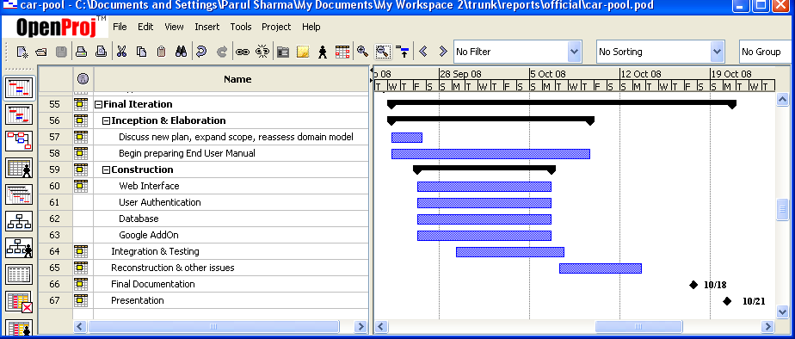
Figure 3: Gantt chart – Final iteration
The final iteration, as has been stated in the Scope for Prototype Three, is going to focus on optimization, security and usability issues. It is obvious from Figure 3 that not many details have been outlined for the project plan of this iteration but this will be ‘fleshed out’ as we reach closer to the middle of the second iteration and have a good measure of our progress and how this will affect the third iteration.

4. Design Documentation

4.1 Domain Model

The domain model is modeled as a class diagram using Unified Modeling Language. It relates the objects that will be in our system’s domain to each other, and helps us identify attributes and methods of these objects.

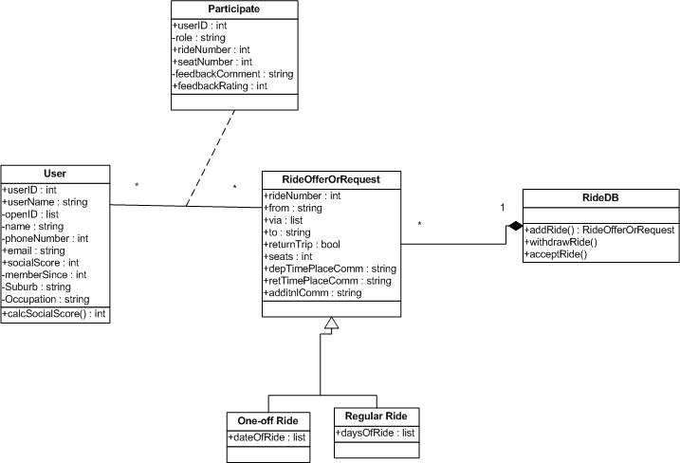

Figure 4: Class Diagram

Note that getters and setters have not been defined as operations for the diagram above. This is because they simply clutter up the diagram and in our opinion they are no more than visual noise.

4.2 Use Case Diagram

The use case diagram helps illustrate the functionality of a system visually in terms of the actors involved, what their goals are and it also helps us identify any dependencies between the use cases.

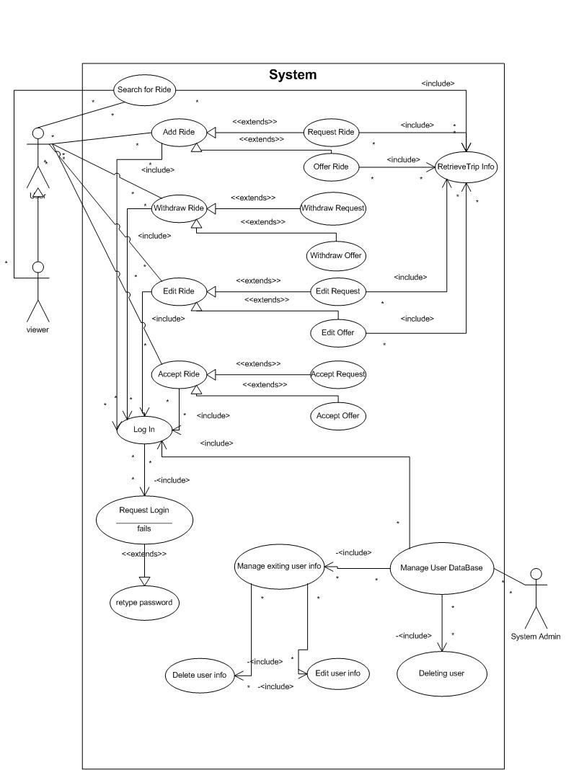

Figure 5: Use Case Diagram

4.3 Use Cases

The use cases describe the interaction between external actors and the system. They are the main frame of reference when constructing the system to ensure that the system does what it is expected to do. Just like the Use Case Diagram they are quite thorough and not just restricted to the first scope because it is good to have a broad vision of the system being built. These use cases may be changed depending on how the customer’s requirements change.

Use Case Name: | Registering on Car Pool site
Actor: | User
Description: | The user should easily be able register on the site so they can start using it. They should be able to use their OpenID account to register instead of having to create a new username and password. The user should then be able to add the rest of their details required for registration.  The system should be able to verify the validity of their OpenID account and save the other details the user has entered.
Pre-condition: | User wishes to be able to use the car pooling website.  The user has an OpenID account.
Typical Course of Events: | Actor:  Step 1. The user clicks on the Register button  Step 3. The user enters their OpenID username.  Step 5. The user enters their OpenID username and password  Step 8. The user sees a form with 2 fields. One of them is a field labelled OpenID account which has the user’s validated OpenID account greyed. They may not edit it. (if they want to edit it they have to get account revalidated) The 2nd field is username so the user chooses a username for themselves and clicks “check username availability”  Step 10. The user clicks “confirm username”  Step 13. The user sees a form with various fields such as email address for notification, phone number, which they fill out appropriately. And finally click on “finish registration” | System:  Step 2. The system takes the user to the Registration Form Step A  Step 4. The system takes the user to the OpenID site.  Step 6. The OpenID site verifies this and if username and password have a match sends system this info.  Step 7. So the system has validated the OpenID account. The user is taken to Registration Form Step B  Step 9. The system checks the database to see if any other user has the same username. If they don’t system tells user they can have the username.  Step 11. The system now has a database instance created with user OpenID account, and username stored and system also issues a userID which is also stored in the database.  Step 12. The system displays Registration Form Step C to user.  Step 14. The rest of the details are added to the system database. The system then displays the homepage with the user account box showing their username and a Logout option beneath it.
Alternative Course A: | Step 7. User tries again. | Step 6. The OpenID site verifies the user’s OpenID account name and password. These fail to match. The system displays a page to the user stating that their OpenID account was not validated. And asks them to try again.  Step 8. If this time it is successful then steps continues as per Typical Course of Events Step 7 else keep repeating Alternative Course A till successful.
Alternative Course B: | Step 10. The user choose another username and clicks “Check Availability again” | Step 9. The system checks the database to see if any other user has the same username. If the name is being used by someone else the system tells user (top of the Registration Form Step B page) they cannot have the username and must choose another on.  Step 11. If username is available then can continue as per Typical Course of Events Step 10 else repeat Alt Course B till successful.
Post-condition | The system now has the user’s details stored in the database  The user has successfully created an account with the system  The user is taken to the homepage where they can choose to do what they want.
Assumption: | Usually the user doesn’t enter the wrong password for their Open ID account.  Usually the username chosen is available.

Use Case Name: | Edit User Details
Actor: | User
Description: | The user should easily be able to change any details they would like to.
Pre-condition: | The user has account on the system.  The user is logged into that account.  The user wishes to change some details of his account (e.g. email, phone etc)
Typical Course of Events: | Actor:  Step 1. The user clicks on the Change Details button  Step 3. The user changes the detail they want to. They are only able to change their: email address, phone. The user clicks the Save Changes button. | System:  Step 2. The system takes the user to the Change Details page.  Step 4. The system saves the changed details appropriately in the database and on the other required pages.  Step 5. The system takes user to a “your details have been successfully changed” page.
Post-condition | The system now has the user’s changed details stored in the database  The user has successfully changed the details they wanted to  The user is taken to a page informing them of their success.
Assumption:

Use Case Name: | Add a Request
Actor: | User
Description: | The user should easily be able to add a Request for a Ride and the system should store the details of this request as the user has entered them.
Pre-condition: | The user has an account with the site.  The user is logged into that account.  The user wants to request a ride from a certain location to another location on a certain date/certain days.
Typical Course of Events: | Actor:  Step 1. The user clicks on the Add Request button  Step 3. The user enters the following details:  Ride From  Ride To  Date  Departure Time  Seats Needed  Step 4: The users presses Add Request button. | System:  Step 2. The system takes the user to the Request Form  Step 5. The system saves the Request details.  Step 6. The system takes the user to a page announcing the Ride has been successfully requested.
Post-condition | The system now has the request details stored in the database  The user has successfully created a request. This request can be accessed from the User’s Account where the user may edit details and withdraw request up till a certain time.  The user is taken to a page informing them the request has been successfully added.
Assumption: | The user has already searched for rides offered and was unable to find one that met their criteria.

Use Case Name: | Add an Offer
Actor: | User
Description: | The user should easily be able to add an offer for a Ride and the system should store the details of this offer as the user has entered them.
Pre-condition: | The user has an account with the site.  The user is logged into that account.  The user wants to offer a ride from a certain location to another location on a certain date/certain days.
Typical Course of Events: | Actor:  Step 1. The user clicks on the Add Offer button  Step 3. The user enters the following details:  a. Ride From  Ride To  Ride Via  b. The user then encounters the option between One-off and Regular and chooses on. The default option is One-off so the next field is: Dates. The user may choose more than one date.  c. The user then can add information regarding approx what time to meet and where.  d. The next field the user fills is of the number of seats available.  e. The last option is if the trip is a return trip or not. The default option is no return trip.  f. The user chooses if they want to receive emails if someone comments on the offer or accepts it.  g. The user finally clicks the Add Offer button. | System:  Step 2. The system takes the user to the Offer Form  Step 5. The system generates an Offer ID and then saves the Offer details associated with it.  Step 6. The system adds the ride to the user’s Google calendar. The system takes the user to a page announcing the Ride has been successfully offered.
Alternative Course A: | Step 3b. The user chooses Regular ride option instead of One off.  Step 5. User chooses the appropriate days and the rest continues from step 3c in Typical Course of Events. | Step 4. System changes the Date of Ride field to one where users get to choose from the Days of the Week what days they will be traveling.
Alternative Course B: | Step 3e. The user chooses Return Trip option.  Step 5. User adds Return Trip details and the rest continues from Step 3f in Typical Course of Events | Step 4. System adds a field for user to add information regarding Return Trip.
Post-condition | The system now has the offer details stored in the database  The user has successfully created an offer. This offer can be accessed from the User’s Account where the user may edit details and withdraw offer up till a certain time.  The user is taken to a page informing them the request has been successfully added.
Assumption: | The user will most often choose to offer a One of Ride without a Return Trip.

Use Case Name: | Accept an Offer
Actor: | User
Description: | The user should easily be able to accept an offer.
Pre-condition: | The user has an account with the site.  The user is logged into that account.  The user has searched for rides and found a ride offer they would like to accept.  The user has, if they wanted to, discussed in the comments of that ride page whatever they need to with the person offering the ride.  The user is on that Ride’s page.
Typical Course of Events: | Actor:  Step 1. The user clicks on the Accept Offer button  Step 3. The user specifies the amount of seats they intend to take up. These cannot be more than the number of seats offered.  Step 4: The user clicks the Accept Offer button. | System:  Step 2. The system takes the user to the Accept Offer Form  Step 6. The system reduces the number of seats available from the offer appropriately. The system adds the ride to the user’s Google calendar. The system takes the user to a page announcing the Ride has been successfully accepted.  Step 7. The system sends the person who offered the Ride an automated email informing them of the acceptance if they chose to receive emails regarding it.
Alternative Course A: | Step 4. The user clicks on the Decline Offer button. | Step 5. The system takes user to a page announcing the offer was not accepted.
Post-condition | The user has depending on what choice they made Accepted the Offer or not. If they accepted the offer then this offer can be accessed from the User’s Account where the user may decline the offer up to a certain period of time. The number of seats available is reduced and the ride is added as an event to the user’s calendar.
Assumption:

Use Case Name: | Accept a Request
Actor: | User
Description: | The user should easily be able to accept a request.
Pre-condition: | The user has an account with the site.  The user is logged into that account.  The user has searched for ride requests and found a ride request they would able to fulfill.  The user has, if they wanted to, discussed in the comments of that ride page whatever they need to with the person requesting the ride.  The user is on that Ride’s page.
Typical Course of Events: | Actor:  Step 1. The user clicks on the Accept Request button  . | System:  Step 2. The system adds the ride to the person who requested and the person who accepted the request’s Google calendar. The system takes the user to a page announcing the Ride Request has been successfully accepted. The system sends the person who requested the Ride an automated email informing them of the acceptance if they chose to receive emails regarding it.
Post-condition | The ride is added as an event to both the users’ calendars. The request is labelled as fulfilled.
Assumption:

Use Case Name: | Edit Request
Actor: | User
Description: | The user should easily be able to change any details they would like to on their request
Pre-condition: | The user has account on the system.  The user is logged into that account.  The user has made a request for a ride  The user wishes to change some details of that ride.  The user is on their Account page which lists their requests and offers.
Typical Course of Events: | Actor:  Step 1. The user clicks on the Edit button beside the appropriate ride request.  Step 3. The user changes the details they want to. The user clicks the Save Changes button. | System:  Step 2. The system takes the user to the Edit Request page.  Step 4. The system saves the changed details appropriately in the database and on the other required pages.  Step 5. The system takes user to a “your request details have been successfully changed” page. The system sends an automated email to anyone who had accepted the request informing them of this. If the request had been accepted previously it no longer is labelled fulfilled. The user who is sent the email can decide if they want to accept again or not.
Alternative Course A: | Step 3. The user clicks Don’t Save Changes. | Step 2. The system takes the user to a page that informs them their changes were not saved.
Post-condition | The system now has the user’s changed details stored in the database  The user has successfully changed the details they wanted to  The user is taken to a page informing them of their success.
Assumption: | The user will only be able to Edit up till one week prior to the date of the ride.

Use Case Name: | Withdraw Request
Actor: | User
Description: | The user should easily be able withdraw their request
Pre-condition: | The user has account on the system.  The user is logged into that account.  The user has made a request for a ride  The user wishes withdraw the request.  The user is on their Account page which lists their requests and offers.
Typical Course of Events: | Actor:  Step 1. The user clicks on Withdraw button beside the appropriate ride.  Step 3. The user clicks Yes. | System:  Step 2. The system takes the user to a “I really want to delete this request” page.  Step 4. The system deletes request details from the database and other pages and displays a “request has been deleted” page to the user. Also the system sends an automated email to anyone who had accepted the request informing them of this.
Alternative Course A: | Step 3. The user clicks No. | Step 2. The system takes the user to a “request has not been deleted” page.
Post-condition | The system now has deleted the request from database and user’s accounts.  The user is taken to a page informing them of this.
Assumption: | The user will often go ahead with the request deletion.  The user will only be able to Withdraw up till one week prior to the date of the ride.

Use Case Name: | Edit Offer
Actor: | User
Description: | The user should easily be able to change any details they would like to on their offer
Pre-condition: | The user has account on the system.  The user is logged into that account.  The user has made an offer for a ride  The user wishes to change some details of that ride.  The user is on their Account page which lists their requests and offers.
Typical Course of Events: | Actor:  Step 1. The user clicks on the Edit button beside the appropriate ride offer.  Step 3. The user changes the details they want to. The user clicks the Save Changes button. | System:  Step 2. The system takes the user to the Edit Offer page.  Step 4. The system saves the changed details appropriately in the database, Google calendar and on the other required pages. The system takes user to a “your offer details have been successfully changed” page.  Step 5. . The system sends an automated email to anyone who had accepted the offer informing them of edit.
Alternative Course A: | Step 3. The user clicks Don’t Save Changes. | Step 2. The system takes the user to a page that informs them their changes were not saved.
Post-condition | The system now has the user’s changed details stored in the database  The user has successfully changed the details they wanted to  The user is taken to a page informing them of this success.
Assumption: | The user will only be able to Edit up till one week prior to the date of the ride.

Use Case Name: | Withdraw Offer
Actor: | User
Description: | The user should easily be able withdraw their offer
Pre-condition: | The user has account on the system.  The user is logged into that account.  The user has made an offer for a ride  The user wishes withdraw the offer.  The user is on their Account page which lists their requests and offers.
Typical Course of Events: | Actor:  Step 1. The user clicks on Withdraw button beside the appropriate ride.  Step 3. The user clicks Yes. | System:  Step 2. The system takes the user to a “I really want to delete this offer” page.  Step 4. The system deletes offer details from the database and other pages such as Google Calendar and displays “offer has been deleted” page to the user.  Step 5. The system sends an automated email to anyone who had accepted the offer informing them of deletion.
Alternative Course A: | Step 3. The user clicks No. | Step 2. The system takes the user to a “offer has not been deleted” page.
Post-condition | The system now has deleted the offer from database and user’s accounts.  The user is taken to a page informing them of this.
Assumption: | The user will often go ahead with the deletion.  The user will only be able to withdraw up till one week prior to the date of the ride.

5. Risk Mitigation Monitoring and Management Plan (RMMM)

The following RMMM was developed in consultation with our team. Mitigation and Monitoring measures have been taken to avoid and keep track of the risks listed and if we do encounter a problem eventually we will be able to employ our Management strategy to deal with it.

Risk | Category | Probability | Impact | Mitigation | Monitoring | Management
Change in requirements means design documentation is no longer valid | Project | 80% | 2 - Critical | This cannot be avoided. The process methodology we use is not focused on Big Design Upfront but instead follows a model-only-as-much-as-you-need approach | Weekly, and after each iteration, discuss the requirements and what is about to be implemented and discuss how this affects design document. | Each time a change is made in the requirements or plan of what is to be implemented all design documents should be updated to reflect the changes. Also document all changes made in weekly team report to manage and keep track of them. Ensure all changes are communicated to appropriate stakeholders.
Security Issues | Technical | 70% | 1 - Catastrophic | Need to decide early on what can access what and who can change what? Make views; ensure users are not interacting with database directly. Use privileged accounts with restrictions. | Continual stress testing | If security vulnerability is identified inform affected stakeholders and find a solution to problem as soon as possible.
Usability Issues with final product | Business | 70% | 2 - Critical | Incorporate in project plan time to ensure site is assessed and redone to follow good HCI principles | Use prototypes and do beta tests. Get user feedback and attempt to solve major issues with User interface. | If after release the interface is seen as having issues see if steps can be taken to solve issues.
Lack of experience with tools/ languages/ concepts | Staff | 70% | 2 - Critical | At onset of project find out which team member has experience and are comfortable with what tools. Choose tools that most members are familiar with. | Continually discuss how the members are finding their experience with new tool/ language/ concept. | If a member is struggling with a certain tool/ language/ concept then hunt appropriate tutorials that will help make one comfortable with tool/ language/ concept. Also ask team manager for help if completely clueless on how to implement something for project
Synchronization of concurrent access | Technical | 70% | 3 - Marginal | Need to look into a solution and incorporate it into database design. | Continual stress testing | When concurrent issues occur use solution found to deal with issue.
Different software tools used in project are incompatible | Technical | 60% | 1 - Catastrophic | Verify compatibility prior to taking decisions regarding using the software/ tool in the project | Ensure throughout integration that all is proceeding as planned | If something is not working and integrating as expected then immediately hunt for solutions that might help with compatibility. If all else fails get on to finding an alternative as soon as possible and begin implementation through that. Reassess project plan in terms of how much this will set back certain tasks.
Failure to integrate the various components successfully | Technical | 60% | 1 - Catastrophic | Ensure all tools being used are compatible. Allow sufficient time for integration of components in project plan. | Keep track of how integration is proceeding as outlined in project plan. | If integration is encountering problems ask help from manager, look up as soon as possible on how to integrate the different components in question, if integration seems impossible work on plan to find an alternate tool that may be used.
Problems within team | Staff | 60% | 2 - Critical | Establish effective communication channels at the onset of the project to ensure everyone is aware of what is going on with team and project. Lack of awareness and a feeling of not being involved leads to frustration | Monitor team morale and ensure through weekly meetings that whole team is aware of how the project is proceeding. Take everyone’s suggestions on board regarding the project. | If a member has an issue with the team or any problem arises do not avoid issue. Try to identify cause of problem and then try to deal with the problem.
Unforeseen dependencies between various tasks | Project | 60% | 3 - Marginal | Identify all components to be built and their dependencies between each other. Develop project plan with aim to maximize concurrency during development | Through weekly meetings ensure that all tasks that can be completed concurrently are being done so if the resources available allow it. | Assign more resources (members) to task that is holding up other tasks and preventing concurrent development.
Web Browser Incompatibility | Technical | 60% | 3 - Marginal | Make sure when coding to look up on how to avoid incompatibility with major/popular browsers. | Test in major/popular environments on a regular basis. | Look for solutions on how to slove incompatibility issue.
Loss of data | Technical | 50% | 1 - Catastrophic | Maintain a backup database | Monitor performance of site and any factors that might cause a crash of the system and thereby loss of data. | Use backup database while trying to recover system.
A team member is not available to work during a crucial time. | Staff | 40% | 3 - Marginal | Ensure that a person is not scheduled to complete a task at a time when they have another assignment due. Ensure everyone is commenting on their bits of code so if another member has to take over they can follow the work. | During weekly team meeting ask if team members have other commitments they need to attend to and if this will impact on their ability to complete the task assigned | If a team member has a sudden emergency to deal with reallocate resources to task they were meant to do depending on how critical the completion of the task is. Reassess project plan.

6. Software Quality Assurance (SQA)

It is important to ensure the quality of the software that is being built and SQA activities can help us do this by ensuring we do not have a lack of conformance to the requirements, explicit or implicit. To this end we plan on implementing the following quality control activities:

6.1 Unit testing

This is important to ensure that individual units in our source code are functioning as expected. For example at the moment we have JUnit tests for the most important methods that we will be using in our application. Figure 6 below shows that these methods are functioning as correctly.
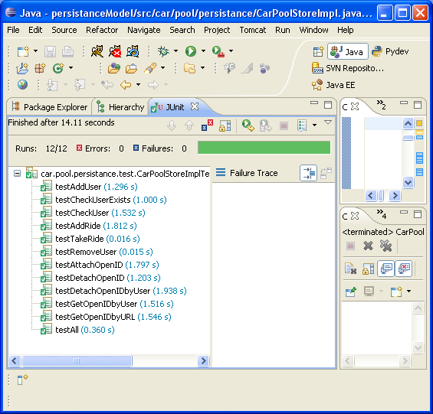

Figure 6: JUnit Tests

6.2 Usability Testing

We will ask various people to beta test our website to identify any areas that users could potentially have issues with. This will be done just prior to starting on prototype two and just after finishing prototype two. Changes will be made to the website depending on what the users recommend will make it easier for them to interact with the website.

6.3 Compatibility Testing

The following is a list of Operating Systems (OS) and web browsers that our website appears and functions correctly in. This list will be expanded to ensure our application has maximum compatibility with the majority of environments it will be accessed from.

Browsers>  OS  V | Internet Explorer | Firefox
Windows XP | OK | OK
Linux | Haven’t tried | OK
Ubuntu | Haven’t tried | OK

6.4 Integration Testing

Successful integration of all components is an essential part of our project. We followed a Bottom Up approach by first testing that our web interface worked with the user authentication and Google modules and finally that all this worked successfully with our database. We will continue to use this approach of testing for all iterations.

6.5 Process Monitoring

This will help us ensure that the steps we take to carry out a process are actually those that we intended to take as stated in our documentation. By ensuring that we adhere to our project methodology we ensure that we are on track with process conformance.

6.6 JDepend
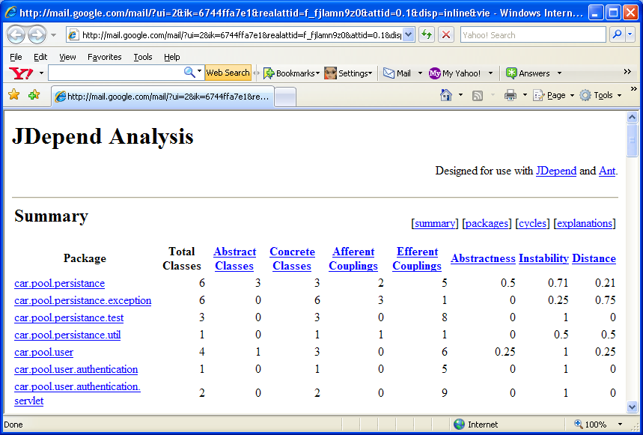
JDepend analysis will help us measure the quality of our design in terms of how extensible, reusable and maintainable it is with regards to managing package dependencies.

Figure 7: JDepend Analysis

